When the North Pole

Became Too Cold

As told to Grandpa Beach

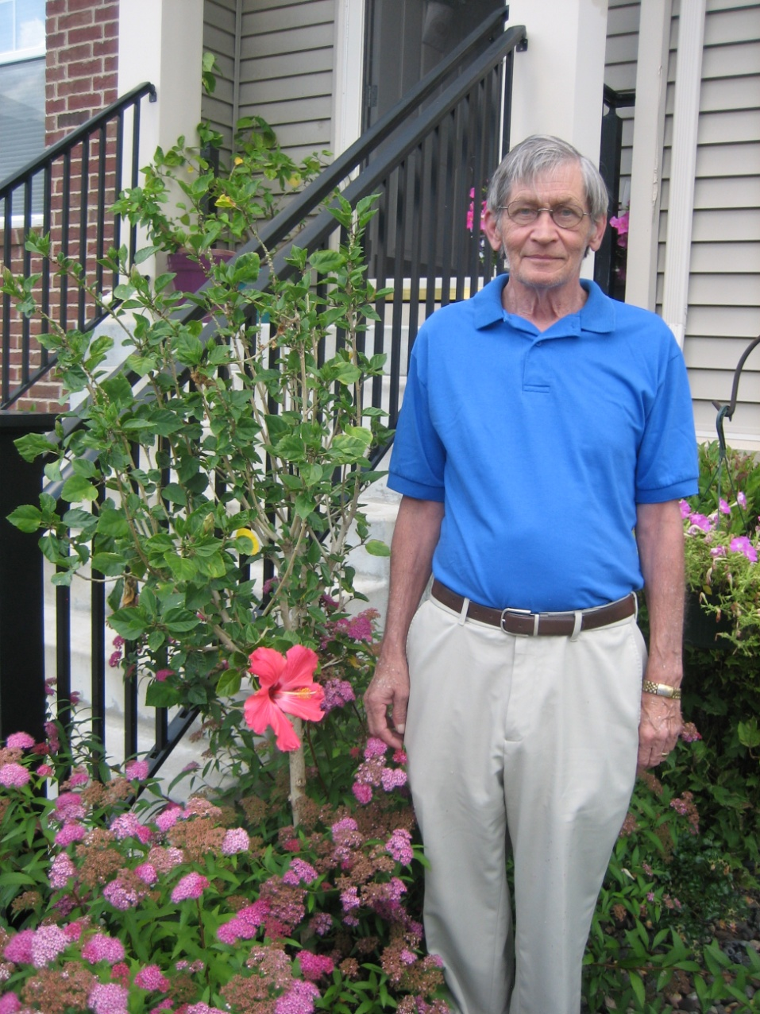





School Version-Older Kids

Copyright © 2013 Xanadu Inc. See Instructions on uses permitted, copying and tailoring to your child/children.

**It was so so cold the bicycles had icicles.**

**It wasn’t fair there was cold everywhere.**

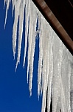

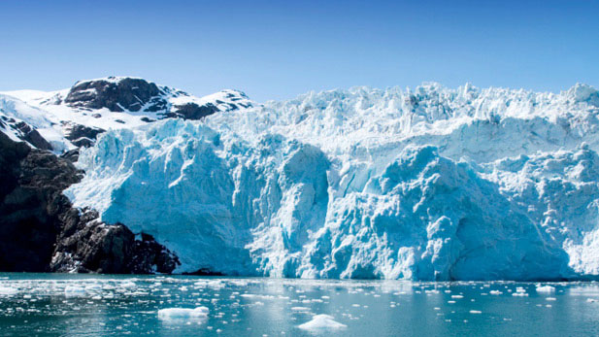

**The sun came up for only one hour.**

**This made the elves quite sour.**

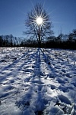

**The snow was in lumps**

**giving everyone goose bumps.**

T**he temperature kept dropping.**

**It seemed like there was no stopping.**

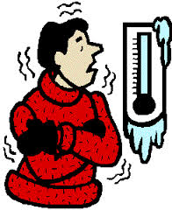

Everyone shivered

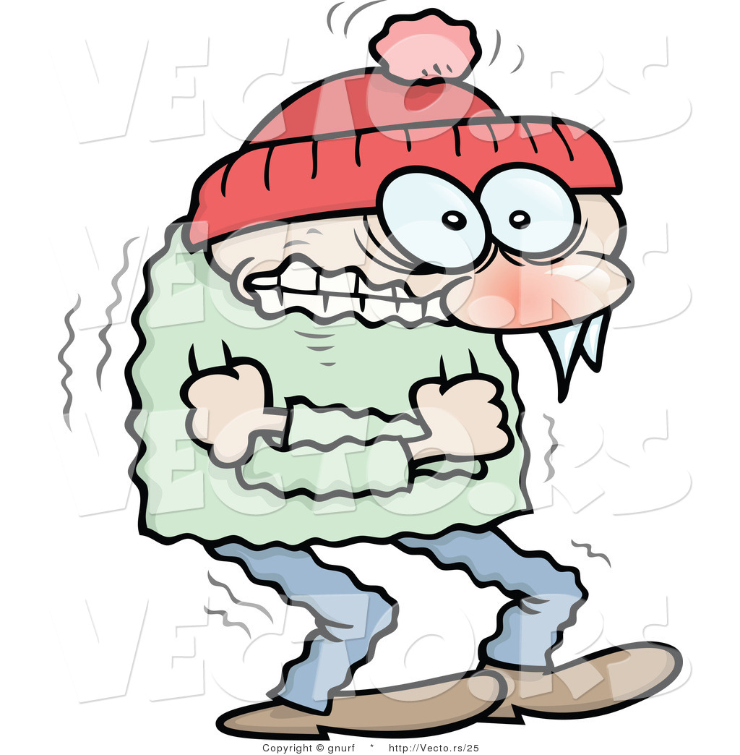

**Especially**

**the elves**

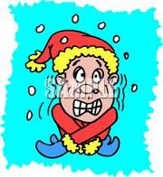

It was so cold!!!

The chubby penguin’s toes froze.



Frosty felt he would never melt.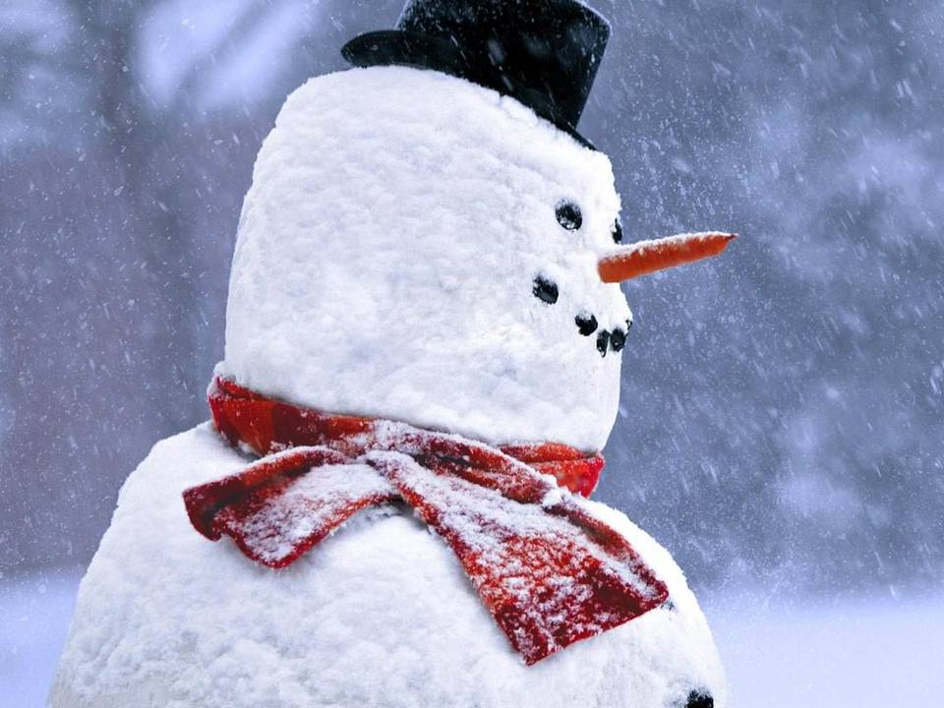

The cold and ice stole

all the fun at the North Pole.

**They called the furnace doctor**

**And you can be sure**

**He tinkered and tried**

**But couldn’t get a temperature.**

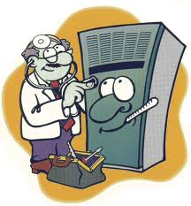

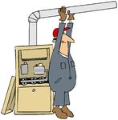

**It wasn’t fair.**

**There was no warm air.**

**The elves told Santa their woes.**

**They were cold from their heads to their toes.**

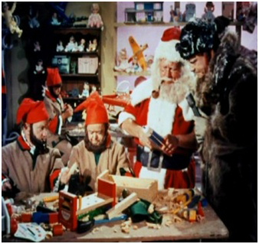

**The evil North Wind watched to make sure.**

**The elves could only shiver and go burrrr.**

The polar bear hid his eyes

and sat on a rock.

The only noise was the Christmas clock going tic tock, tic tock.

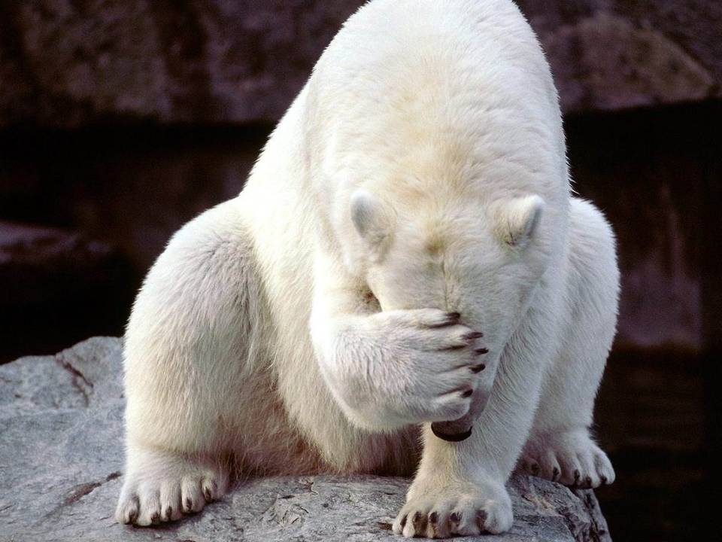

**At the North Pole there was no joy.**

**It was too cold to make even one toy.**

**The poor bear shivered and shook**

**And was so sad he couldn’t look.**

It was really quite a site

Everywhere it was only white.

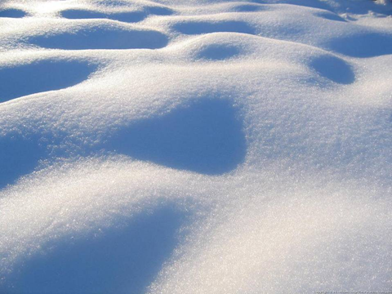

Even in the park the snow left its mark!!!

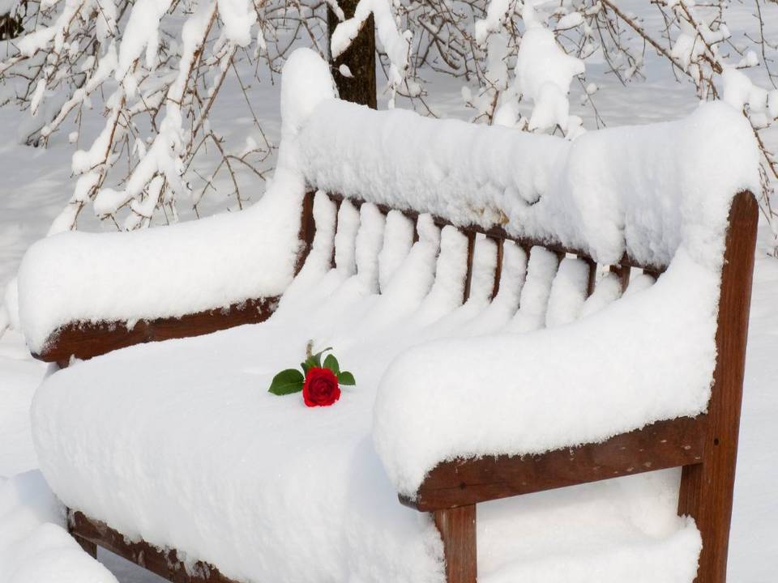

Bad luck.

The baby seal got stuck.

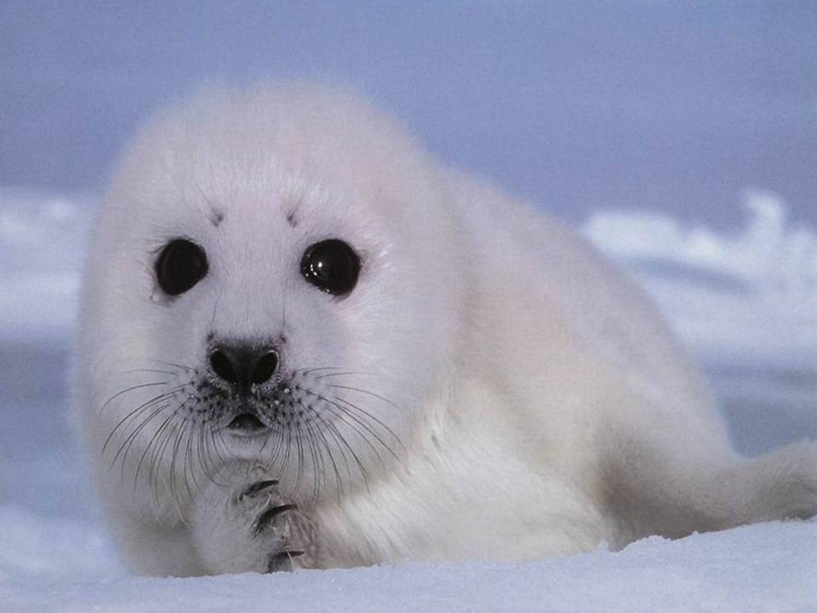

It wasn’t nice napping on the ice.

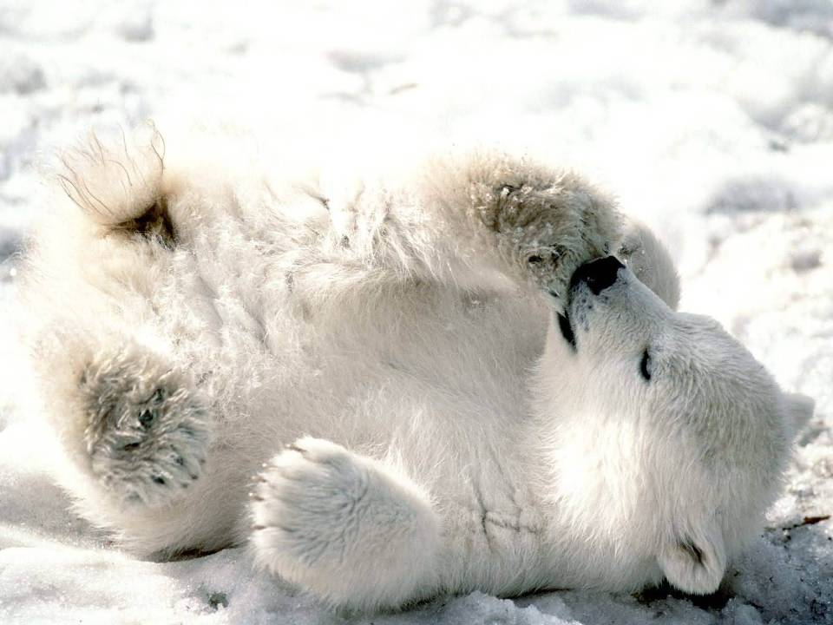

The reindeer complained cold were their feet and there was nothing to eat.

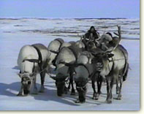

The penguins had a race to leave the place.

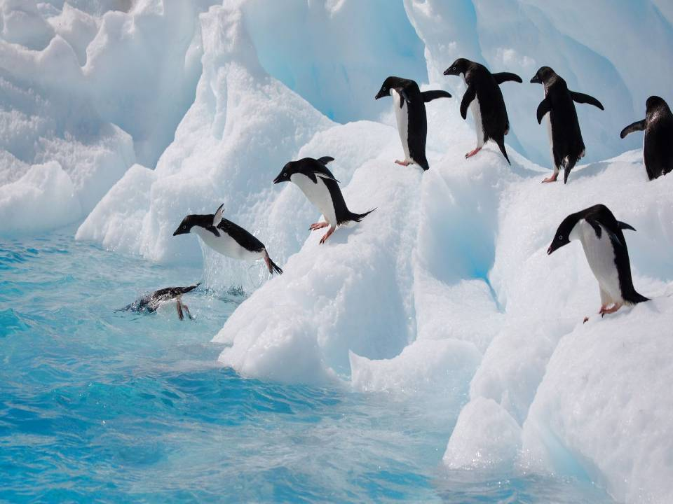

It wasn’t fair. The ice was everywhere.

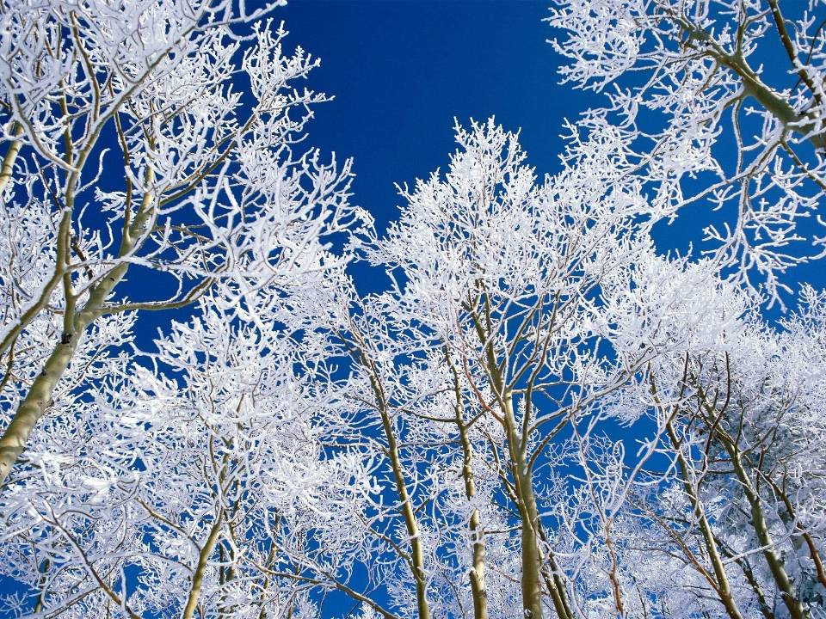

Santa was jumpy and grumpy

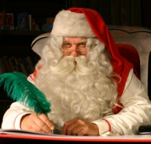

[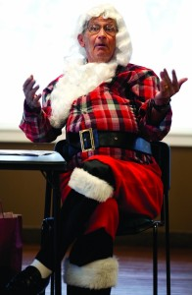](http://pressnews.com/wp-content/uploads/2012/12/MGsantaRetires7.jpg)

Santa said, “I’m sorry to say

We may need to cancel the holiday.”

The elves, reindeer, all of Santa’s team

let out a giant outdoor scream.



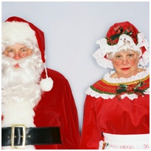

**“Cancel Christmas what a thought.**

**No gifts to give the children will be distraught.”**

“Oh me, oh my.

All the children will cry.

We need candy canes and toys,

and piles of smiles.”



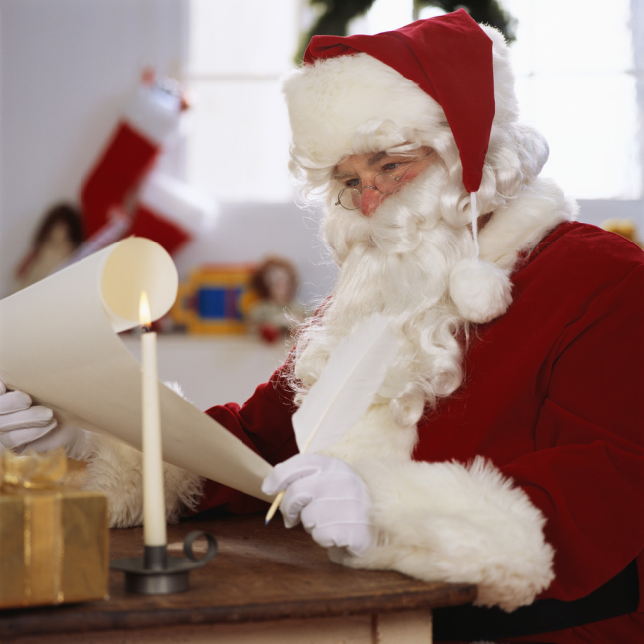

Santa checked his list not once but twice.

Of who was naughty or nice.

From his list he understood

For a year Amelia Beach age 6 had been good.

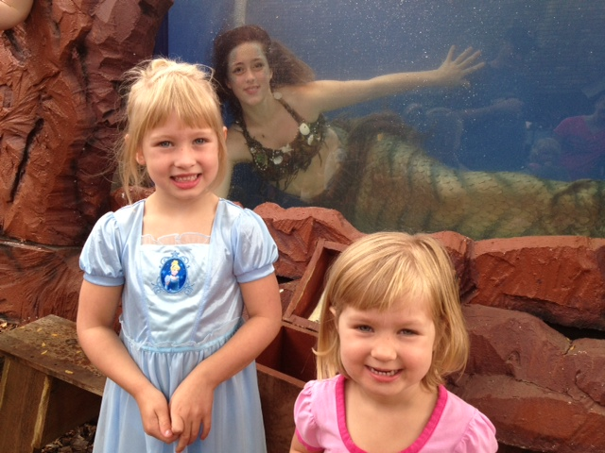

Change text and Insert picture.

No presents to bring would be a terrible thing

It would be bad, They would be sad

I fear it would make Amelia and even her baby sister Lulu very ….

GRUMPY

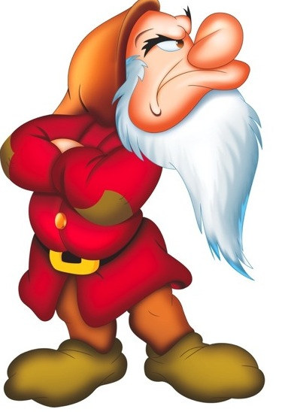

**At the North Pole where they stood**

**they had a pile of money doing them no good.**



[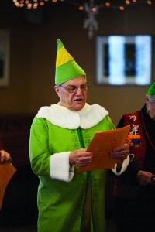](http://pressnews.com/wp-content/uploads/2012/12/MGsantaRetires3.jpg)

“We could use our cash, our stash to buy..

A giant truck

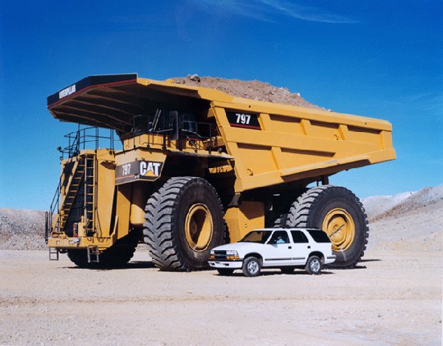

To dig a giant hole

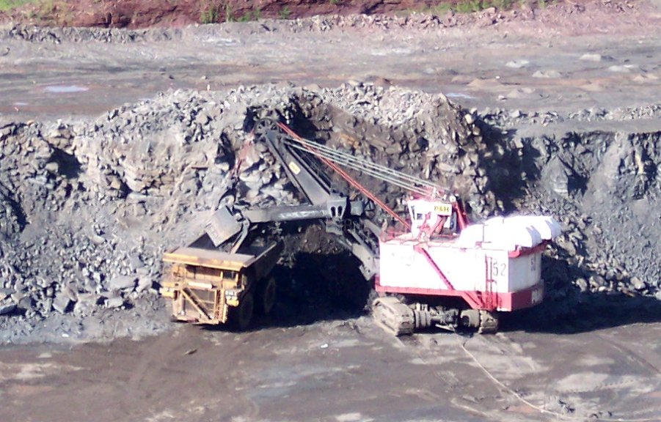

To find a geyser for the heat and steam

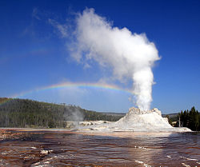

Or to dig a tunnel it would seem

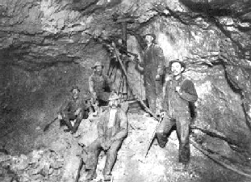

Santa was running out of time

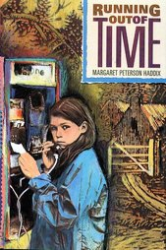

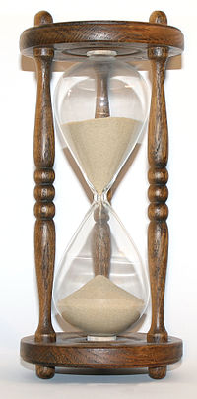

The days before Christmas were few

What in the world could they all do?

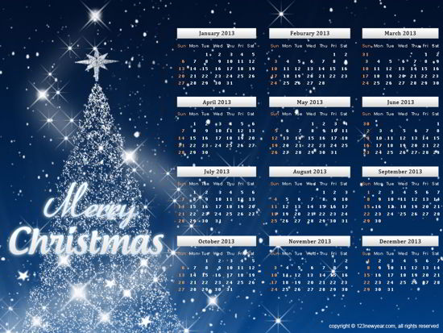

Elves came to help from near and far.

By plane, sled, train, by any means,

from even the land of dreams.

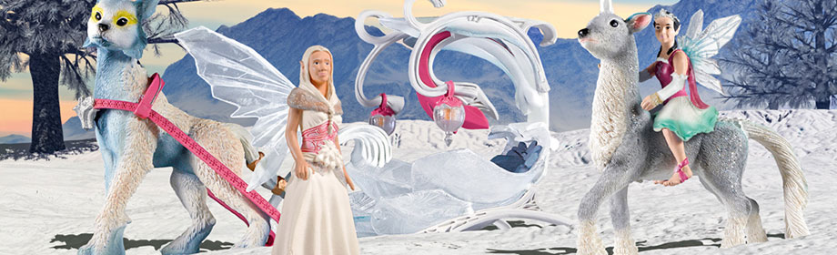

The keebler Elf left his tree to come to see.

The elf who lived with Harry Potter

came to help make it hotter.

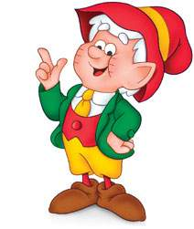 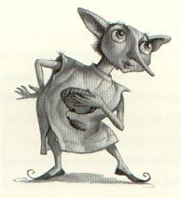

Some elves very old

left their warm caves for the cold.

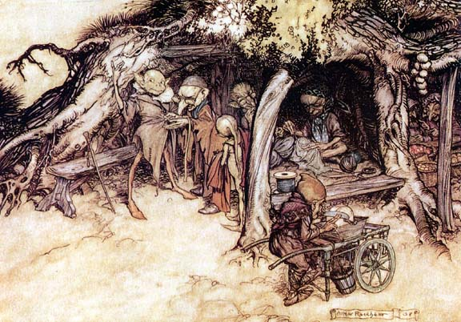

From the Netherlands come they must

Fairy elves with pixie dust.

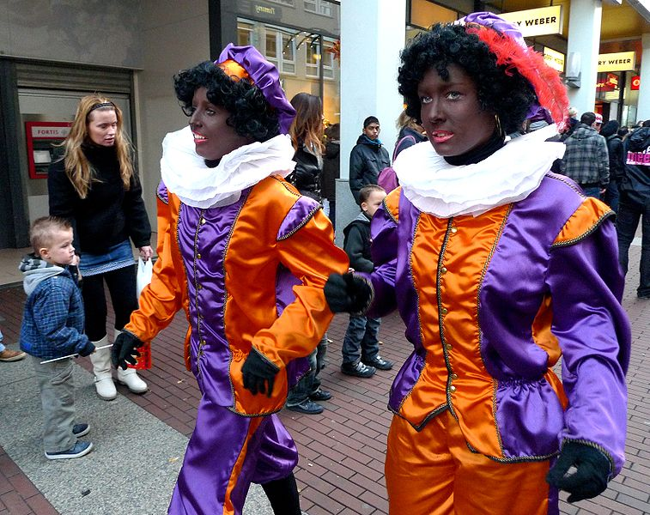



The North Pole elves with cheer and food

tried to make a happy mood.

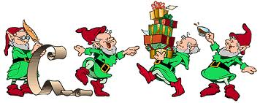

More elves came with magic and stars

and one with a bag of old Mars candy bars.

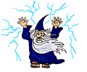 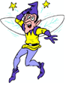 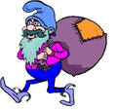

They said, we cannot leave

until we save Christmas Eve.

But nothing seemed to work.

They met for hours every day

but came up with no plan, no way.

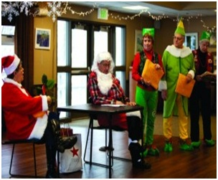

Santa was discusted, discouraged, and upset

He left his sack and turned his back.

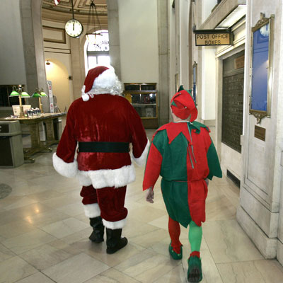

There’s nothing more to say.

Santa walked away.

One of the elves, Northrop, was very very smart

He knew which came first, the horse or the cart.

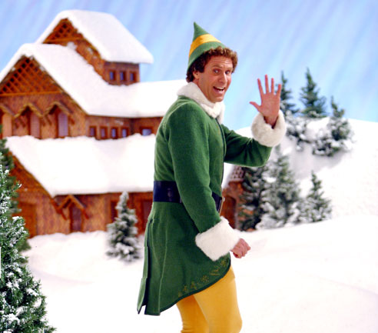

He knew The North Pole was just a place.

They could make their toys in another space.

To Amelia’s school in St Louis Park Northrop went

To visit, to get a hint.

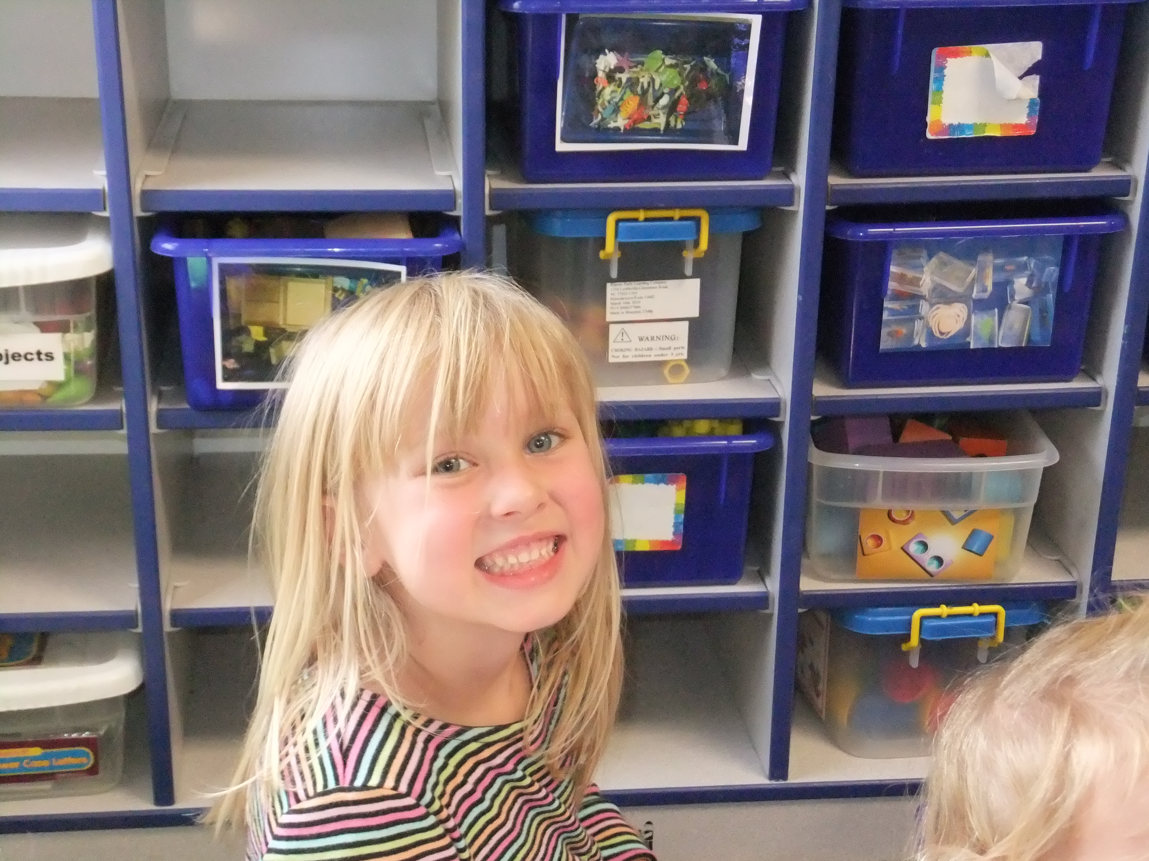

And

He thought and thought and thought

He thought of the strories he had been told

of times of hunger and cold in days of old.

Said Northrop who was very sage

“It was the same in the Ice Age.”

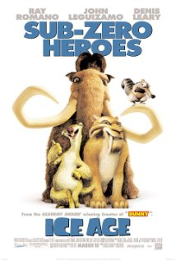

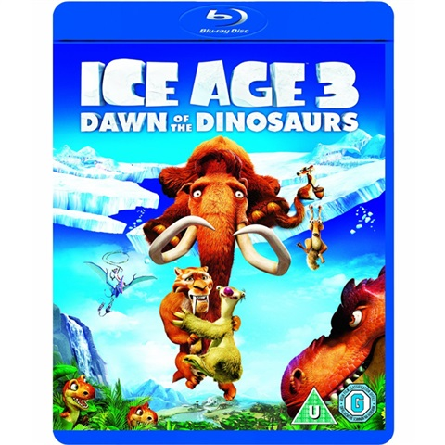

When the snow and ice became to cold to stand

The animals moved to another land.

Rudolf said,

“Lets go where we can play golf.”

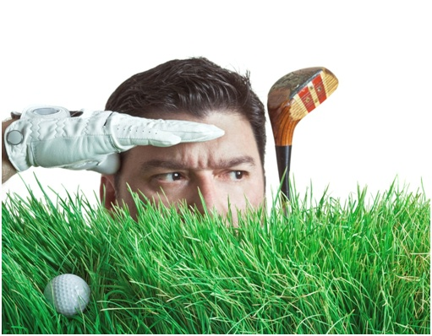

“No. Somewhere we can swim!!”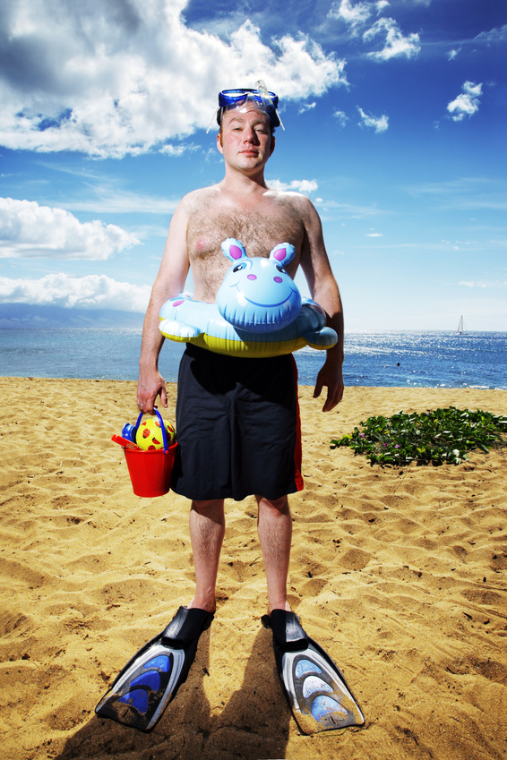

“Skip the sand. Let’s move to Disneyland.”

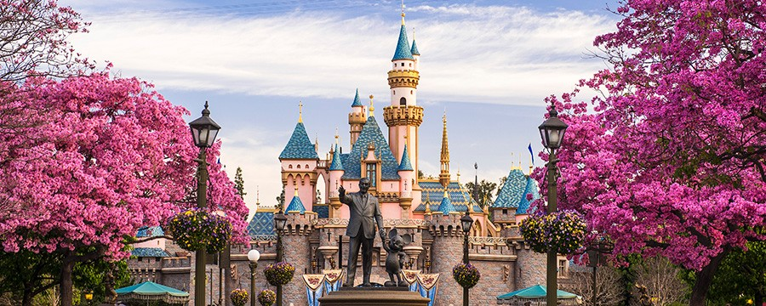

“The sleigh is old and hard to load

Let’s get a truck and drive on a road.”

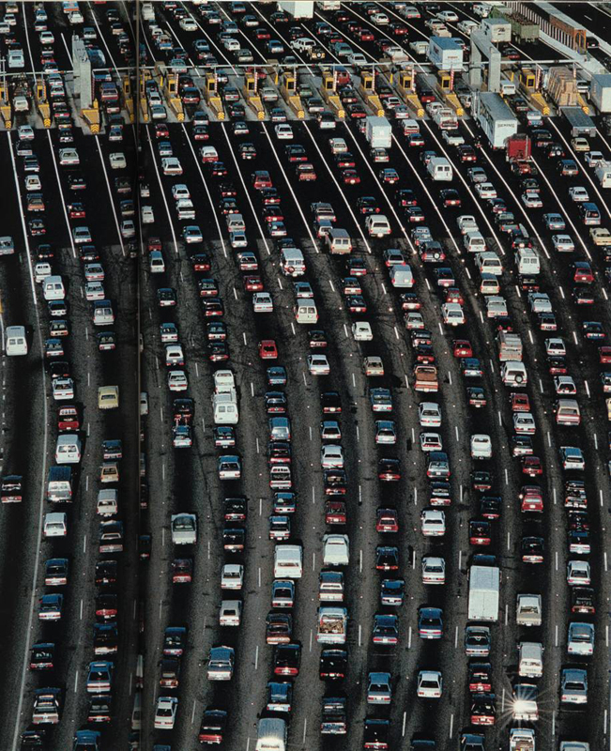

**“NO!! No!! No!!**

**None of these will do**

**But I will give you a clue.”**

**“Imagine a place that has white sand beaches, clear blue water, swaying palm trees, beautiful sunsets, and even a few roads.”**

On the globe Northrop pointed to a dot.

“That’s where we go, that’s our spot.”

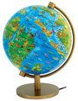

When it became too cold to stand

the people and animals moved to another land.

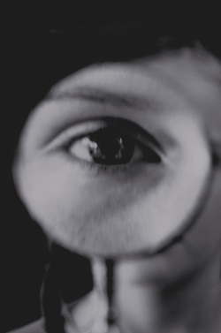

**If you magnify your eye and look very carefully…**

**Off Australia in the Indian Ocean you will see.**

There are three islands very small

Perfect for elves who are not at all tall

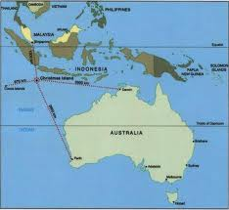

“The biggest has two roads & with luck we will even find a truck.”

“These islands have beautiful sunsets.”

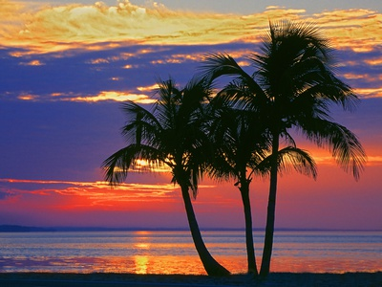

“Beautiful blue water and

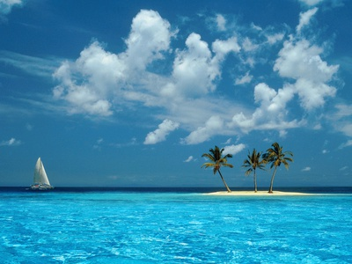

sparkling sandy beaches.”

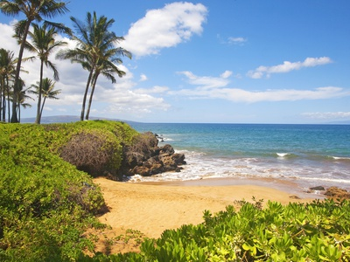

“The biggest of these islands is perfect

The best I could detect.”

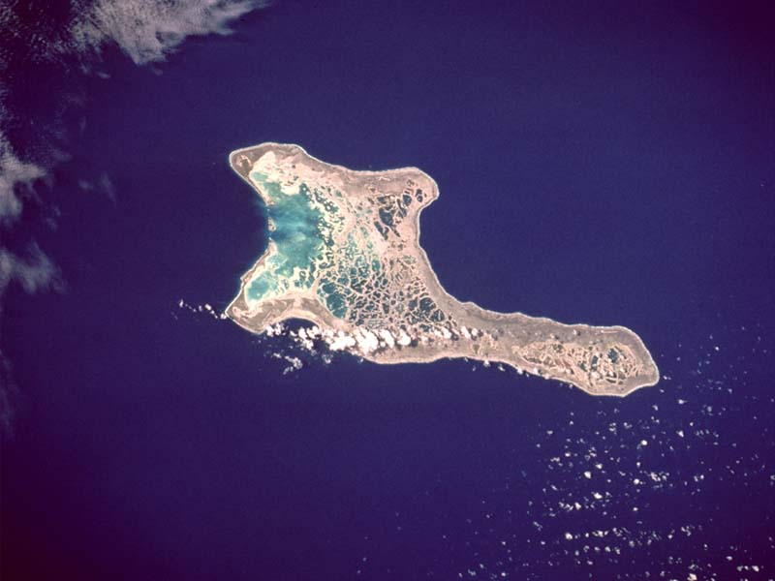

“And you see the islands have a name

Our holiday is called the same.”

“All the children hang their stocking and say the stockings will be full on what day?”

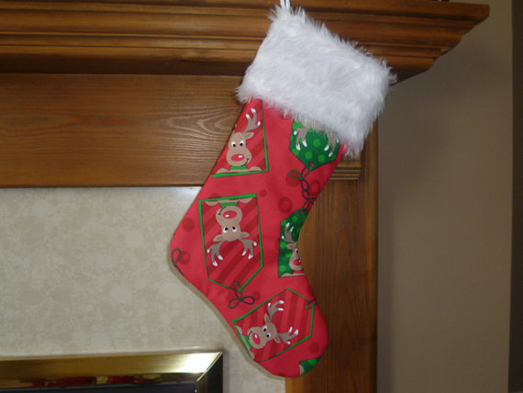

And the children said

“On Christmas Day.”

Santa will move to …..

“The Christmas Islands”

The entire Beach family clapped

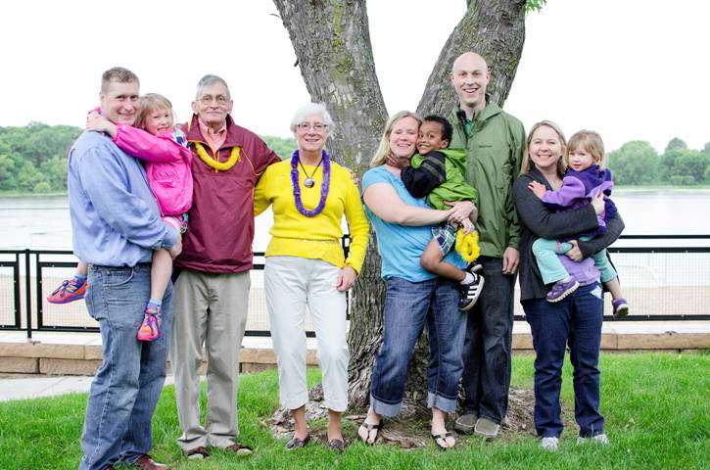

Insert Picture of Family or Group.

“The entire school class clapped or

All of the Minneapolis family clapped.”

And clapped

**And everyone said**





The elves was happy

MC900140891.WMF



The reindeer were happy

The reindeer were happy

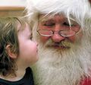

Santa was happy All the children were happy to see Santa

All over the world crowds gave up their fears

Santa is coming they yelled in loud cheers.

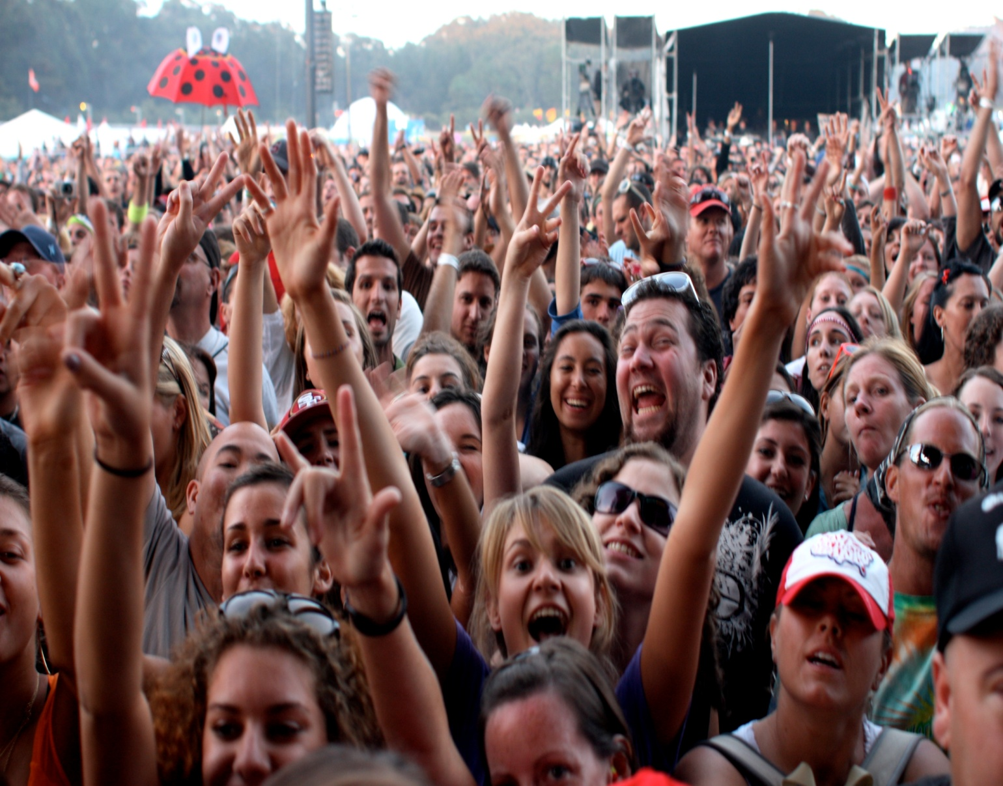

Only Grumpy complained…

**“But I don’t know how to swim and the sun doesn’t dim. I’ll need to learn how not to get a sunburn. I’ll miss my icicles.”**

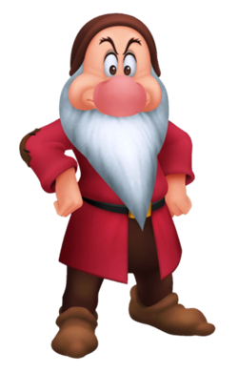

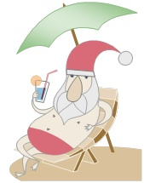

After that Christmas truth be told

Santa started to miss the cold

and sitting in the sun became kind of old.

Then they did learn

The North Pole had warmed up, they could return.

Only Grumpy complained



**It’s too cold to wear my swimming suit, I dislike icicles, and now I have to take the wheels off the sleigh.**

As you might guess

they took the North Pole Express

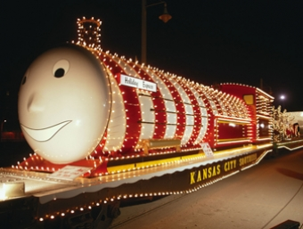

It was a splendid treat.

They took the sleigh to their very own street.

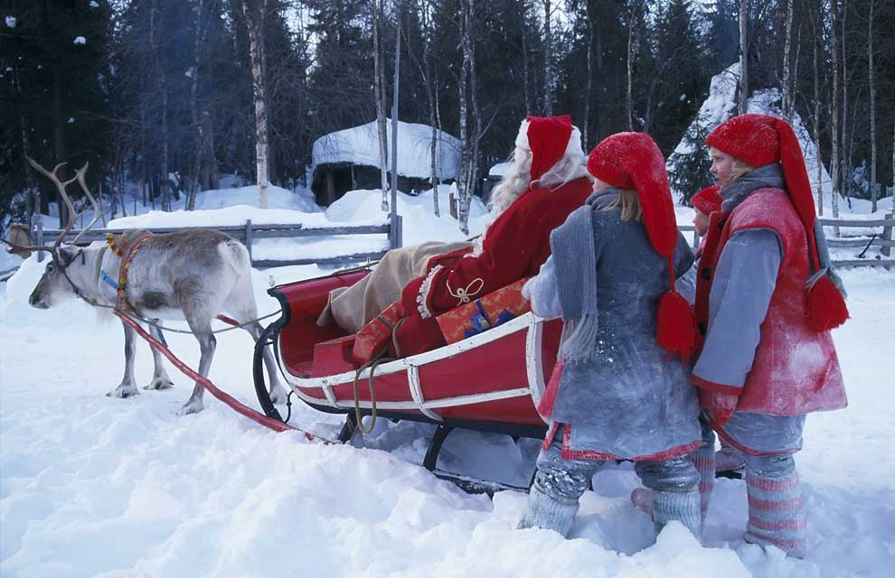

On being home all they could say was hooray!

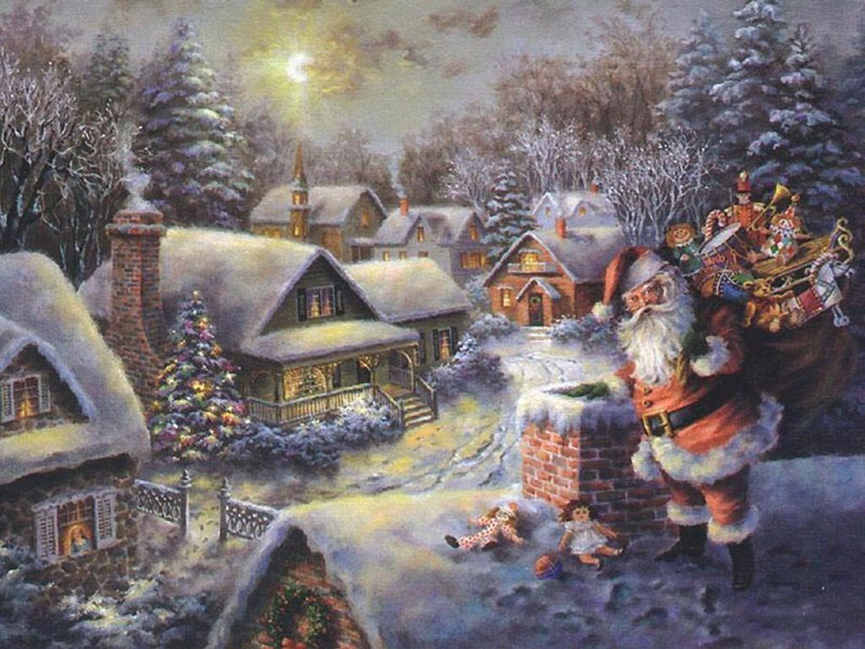

Santa had all of his joys.

Reading his stories by the fire and making toys.

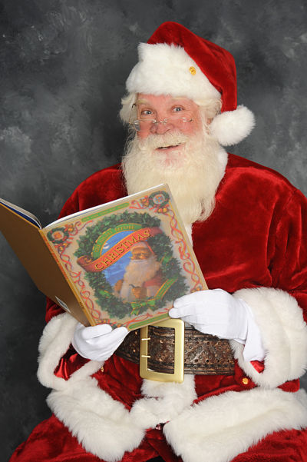 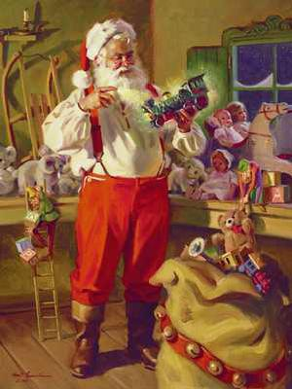 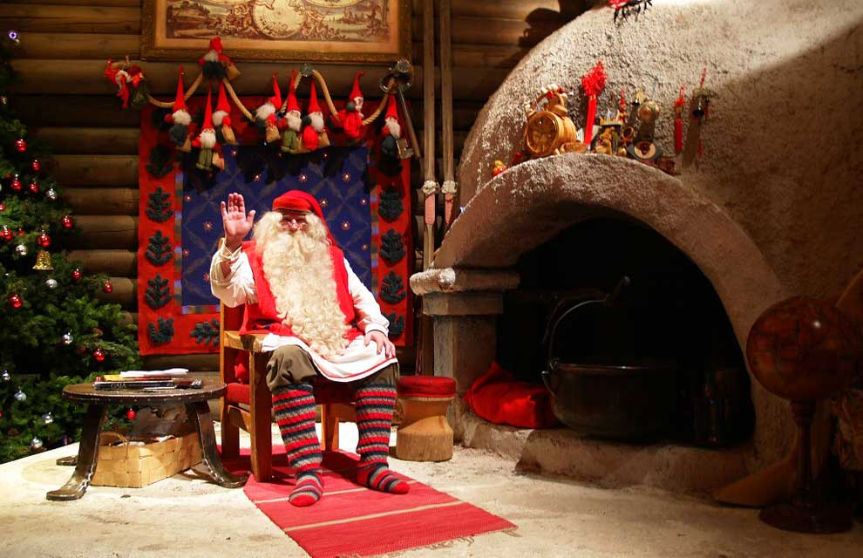

And there was a special note to Amelia 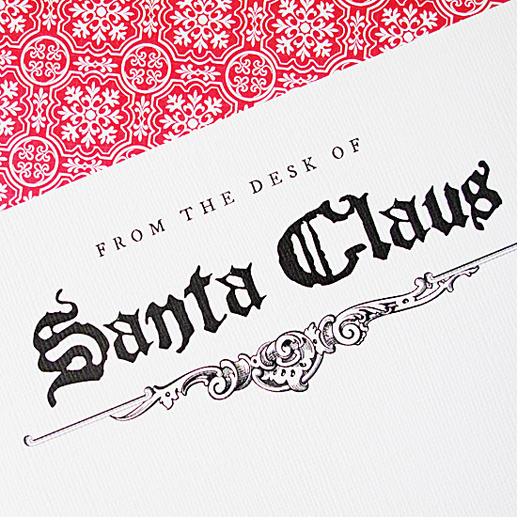

Dear **Amelia**

I had a wonderful time swimming and surfing. It was almost like a vacation, but I am glad to be home. If you want to see where those islands are, you and your parents can find the Christmas Islands on a map, or a globe or the internet.

I am now busy making presents and toys for this coming Christmas in my cozy warm workshop. I will see you soon.

Love Santa

